**Name : DEEBAK KUMAR K**

**Reg No :** 192324064

**Course Code:** DSA0208

**Course Name:** computer vision with opencv for medical applications

**LAB EXPERIMENTS**

**EXP - 1**

**Perform basic Image Handling and processing operations on the image.**

* **Read an image in python and Convert an Image to Grayscale CODE:**

import cv2

image = cv2.imread(r"C:\Users\antoc\OneDrive\Desktop\Course CV\LAB\src\img1.png") #

Replace with your image file name if image is None:

print("Error: Image not found or unable to read.") else:

cv2.imshow('Original Image', image)

gray_image = cv2.cvtColor(image, cv2.COLOR_BGR2GRAY) cv2.imshow('Grayscale Image', gray_image) cv2.imwrite('grayscale_output.jpg', gray_image) cv2.waitKey(0)

cv2.destroyAllWindows()

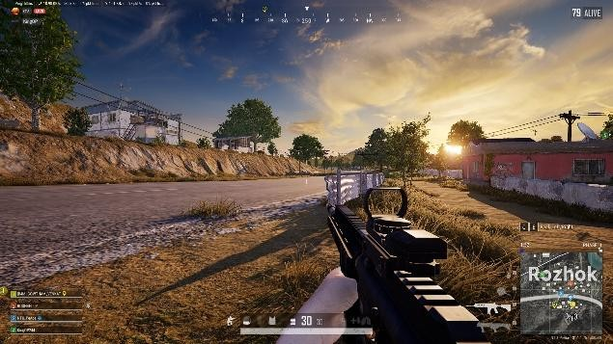**Input :**

**Output :**

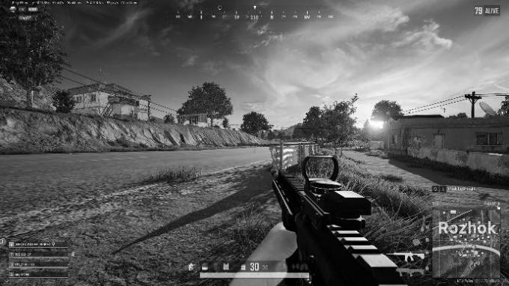

**EXP - 2**

**Perform basic Image Handling and processing operations on the image**

* **Read an image in python and Convert an Image to Blur using GaussianBlur.**

**CODE :**

import cv2

image = cv2.imread(r"C:\Users\antoc\OneDrive\Desktop\Course CV\LAB\src\img1.png") # Replace with your image filename

if image is None:

print("Error: Image not found or unable to read.") else:

cv2.imshow('Original Image', image)

blurred_image = cv2.GaussianBlur(image, (15, 15), 0) # (15,15) is kernel size cv2.imshow('Blurred Image', blurred_image) cv2.imwrite('blurred_output.jpg', blurred_image)

cv2.waitKey(0) cv2.destroyAllWindows()

**Input :**

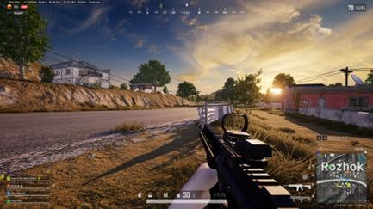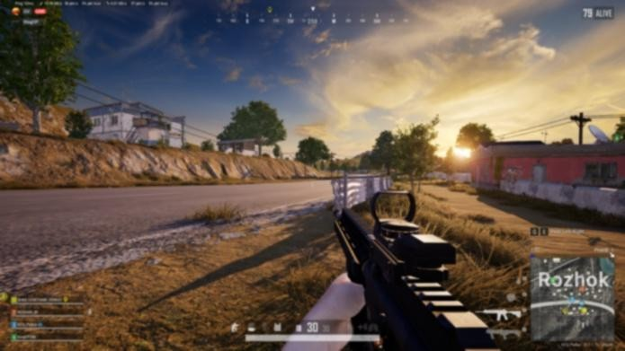**Output :**

**EXP - 3**

**Perform basic Image Handling and processing operations on the image**

* **Read an image in python and Convert an Image to show outline using Canny function.**

**CODE:**

import cv2

image = cv2.imread(r'C:\Users\antoc\OneDrive\Desktop\Course CV\LAB\src\img1.png') # Replace with your actual image filename

gray_image = cv2.cvtColor(image, cv2.COLOR_BGR2GRAY) blurred_image = cv2.GaussianBlur(gray_image, (5, 5), 0)

edges = cv2.Canny(blurred_image, threshold1=50, threshold2=150) cv2.imshow('Original Image', image)

cv2.imshow('Canny Edge Detection', edges) cv2.waitKey(0)

cv2.destroyAllWindows()

**Input :**



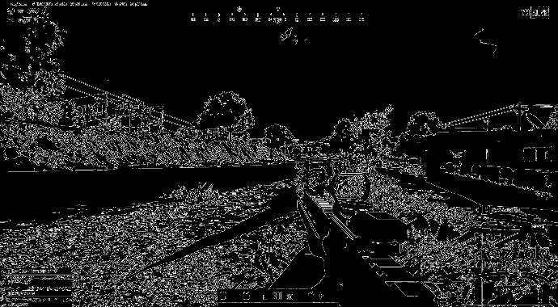**Output :**

**EXP - 4**

**Perform basic Image Handling and processing operations on the image**

* **Read an image in python and Dilate an Image using Dilate function.**

**CODE:**

import cv2

import numpy as np

image = cv2.imread(r'C:\Users\antoc\OneDrive\Desktop\Course CV\LAB\src\img1.png') # Replace with your actual image filename

gray_image = cv2.cvtColor(image, cv2.COLOR_BGR2GRAY)

kernel = np.ones((5, 5), np.uint8) # You can adjust the size for stronger/weaker dilation dilated_image = cv2.dilate(gray_image, kernel, iterations=1)

cv2.imshow('Original Image', image) cv2.imshow('Dilated Image', dilated_image) cv2.waitKey(0)

cv2.destroyAllWindows()

**OUTPUT:**



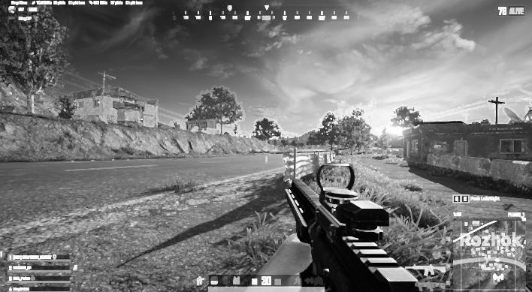**Output :**

**EXP - 5**

**Perform basic Image Handling and processing operations on the image**

* **Read an image in python and Erode an Image using erode function.**

**CODE:**

import cv2

import numpy as np

image = cv2.imread(r'C:\Users\antoc\OneDrive\Desktop\Course CV\LAB\src\img1.png') # Replace with your image file

gray_image = cv2.cvtColor(image, cv2.COLOR_BGR2GRAY)

kernel = np.ones((5, 5), np.uint8) # You can adjust the size for different effects eroded_image = cv2.erode(gray_image, kernel, iterations=1) cv2.imshow('Original Image', image)

cv2.imshow('Eroded Image', eroded_image) cv2.waitKey(0)

cv2.destroyAllWindows()

**INPUT :**



**OUTPUT :**

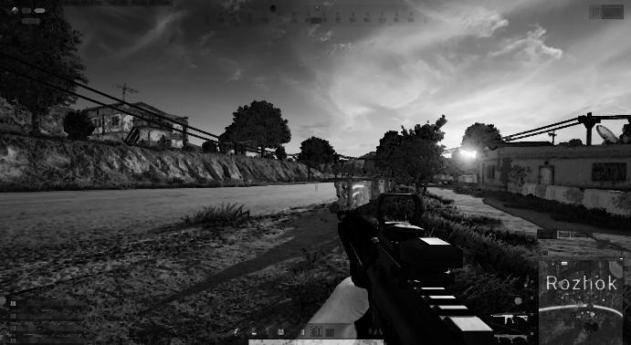

**EXP - 6.**

**Perform basic video processing operations on the captured video**

* **Read captured video in python and display the video, in slow motion and in fast motion. CODE:**

import cv2

video_path = r'C:\Users\antoc\OneDrive\Desktop\Course CV\LAB\src\shotray. cap = cv2.VideoCapture(video_path)

if not cap.isOpened():

print("Error: Could not open video.") exit() print("Select Playback Mode:")

print("1. Normal Speed") print("2. Slow Motion") print("3. Fast Motion")

mode = input("Enter option (1/2/3): ") if mode == '1':

delay = int(1000 / 30) # Normal: 30 FPS elif mode == '2':

delay = int(1000 / 10) # Slow Motion: ~10 FPS elif mode == '3':

delay = int(1000 / 60) # Fast Motion: ~60 FPS else:

print("Invalid option. Playing at normal speed.") delay = int(1000 / 30)

while True:

ret, frame = cap.read() if not ret:

break

cv2.imshow('Video Playback', frame)

if cv2.waitKey(delay) & 0xFF == ord('q'): break

cap.release() cv2.destroyAllWindows()

**EXP – 7**

**Capture video from web Camera and Display the video, in slow motion and in fast motion. CODE:**

import cv2

cap = cv2.VideoCapture(0) if not cap.isOpened():

print("Error: Could not open webcam.") exit()

print("Select Webcam Playback Mode:") print("1. Normal Speed")

print("2. Slow Motion") print("3. Fast Motion")

mode = input("Enter option (1/2/3): ") if mode == '1':

delay = int(1000 / 30) # Normal: ~30 FPS elif mode == '2':

delay = int(1000 / 10) # Slow Motion: ~10 FPS elif mode == '3':

delay = int(1000 / 60) # Fast Motion: ~60 FPS else:

print("Invalid option. Defaulting to Normal Speed.") delay = int(1000 / 30)

print("Press 'q' to quit.") while True:

ret, frame = cap.read() if not ret:

print("Error: Failed to capture frame.") break

cv2.imshow('Webcam Video', frame)

if cv2.waitKey(delay) & 0xFF == ord('q'): break

cap.release() cv2.destroyAllWindows()

**EXP – 8**

**Scaling an image to its Bigger and Smaller sizes. CODE :**

import cv2

image = cv2.imread(r'C:\Users\antoc\OneDrive\Desktop\Course CV\LAB\src\img1.png') # Replace with your image path

if image is None:

print("Error: Image not found or unable to read.") exit()

smaller_image = cv2.resize(image, None, fx=0.5, fy=0.5, interpolation=cv2.INTER_AREA) bigger_image = cv2.resize(image, None, fx=1.5, fy=1.5, interpolation=cv2.INTER_LINEAR) cv2.imshow('Original Image', image)

cv2.imshow('Smaller Image (50%)', smaller_image) cv2.imshow('Bigger Image (150%)', bigger_image) cv2.imwrite('scaled_smaller.jpg', smaller_image) cv2.imwrite('scaled_bigger.jpg', bigger_image) cv2.waitKey(0)

cv2.destroyAllWindows()

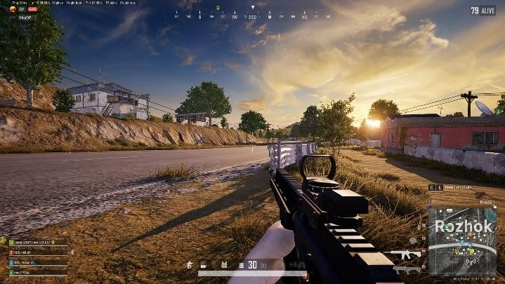**OUTPUT :**

**Bigger Scale:**

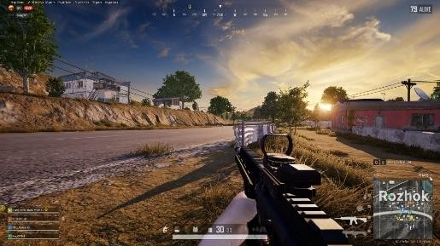**Smaller Scale :**

**EXP – 9**

**Perform Rotation of an image to clockwise and counter clockwise direction. CODE:**

import cv2

image = cv2.imread(r'C:\Users\antoc\OneDrive\Desktop\Course CV\LAB\src\img2.jpg') # Replace with your image file

if image is None:

print("Error: Image not found or unable to read.") exit()

(h, w) = image.shape[:2] center = (w // 2, h // 2)

clockwise_matrix = cv2.getRotationMatrix2D(center, -90, 1.0) clockwise_rotated = cv2.warpAffine(image, clockwise_matrix, (w, h)) counter_matrix = cv2.getRotationMatrix2D(center, 90, 1.0) counter_rotated = cv2.warpAffine(image, counter_matrix, (w, h)) cv2.imshow('Original Image', image)

cv2.imshow('Clockwise Rotation (90°)', clockwise_rotated) cv2.imshow('Counter-Clockwise Rotation (90°)', counter_rotated) cv2.imwrite('rotated_clockwise.jpg', clockwise_rotated) cv2.imwrite('rotated_counter.jpg', counter_rotated) cv2.waitKey(0)

cv2.destroyAllWindows()

**OUTPUT**

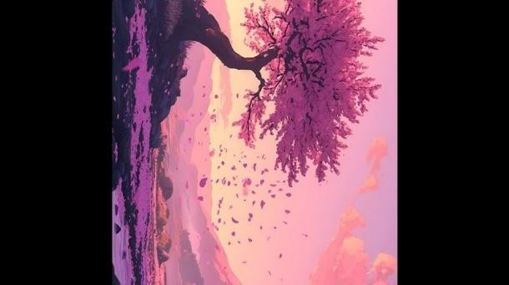**Clockwise**:

**Counter Clockwise:**

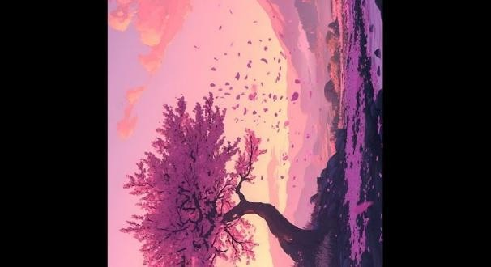

**EXP -10**

**Perform moving of an image from one place to another. CODE:**

import cv2

import numpy as np

image = cv2.imread(r'C:\Users\antoc\OneDrive\Desktop\Course CV\LAB\src\img3.jpg') if image is None:

print("Error: Image not found or unable to read.") exit()

# Move image 100 pixels right and 50 pixels down tx = 100 # shift along X-axis

ty = 50 # shift along Y-axis

translation_matrix = np.float32([[1, 0, tx], [0, 1, ty]]) height, width = image.shape[:2]

translated_image = cv2.warpAffine(image, translation_matrix, (width + tx, height + ty)) cv2.imshow('Original Image', image)

cv2.imshow('Moved Image', translated_image) cv2.imwrite('translated_image.jpg', translated_image) cv2.waitKey(0)

cv2.destroyAllWindows()

**INPUT:**

**OUTPUT:**

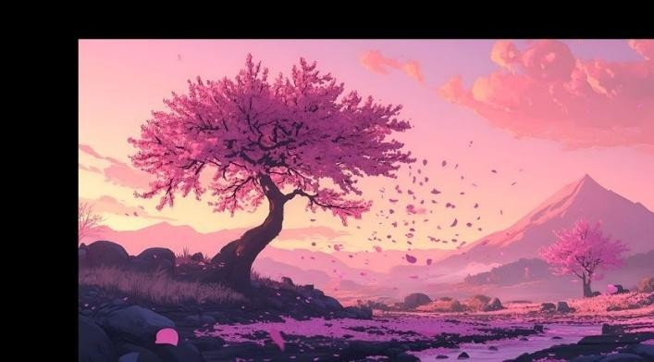

**EXP – 11**

**Perform Affine Transformation on the image. CODE:**

import cv2

import numpy as np

image = cv2.imread(r'C:\Users\antoc\OneDrive\Desktop\Course CV\LAB\src\img3.jpg') if image is None:

print("Error: Image not found or unable to read.") exit()

rows, cols = image.shape[:2]

pts1 = np.float32([[50, 50], [200, 50], [50, 200]])

pts2 = np.float32([[10, 100], [200, 50], [100, 250]])

M = cv2.getAffineTransform(pts1, pts2)

affine_transformed = cv2.warpAffine(image, M, (cols, rows)) cv2.imshow('Original Image', image)

cv2.imshow('Affine Transformed Image', affine_transformed) cv2.imwrite('affine_transformed.jpg', affine_transformed) cv2.waitKey(0)

cv2.destroyAllWindows()

**INPUT:**



**OUTPUT:**

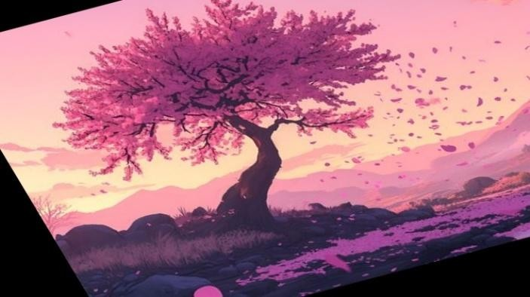

**EXP – 12**

**Perform Perspective Transformation on the image. CODE:**

import cv2

import numpy as np

image = cv2.imread(r'C:\Users\antoc\OneDrive\Desktop\Course CV\LAB\src\img3.jpg') if image is None:

print("Error: Image not found or unable to read.") exit()

rows, cols = image.shape[:2]

pts1 = np.float32([[50, 50], [cols - 50, 50], [50, rows - 50], [cols - 50, rows - 50]])

pts2 = np.float32([[0, 0], [cols, 0], [0, rows], [cols, rows]]) matrix = cv2.getPerspectiveTransform(pts1, pts2)

perspective_transformed = cv2.warpPerspective(image, matrix, (cols, rows)) cv2.imshow('Original Image', image)

cv2.imshow('Perspective Transformed Image', perspective_transformed) cv2.imwrite('perspective_transformed.jpg', perspective_transformed) cv2.waitKey(0)

cv2.destroyAllWindows()

**INPUT:**



**OUPUT:**



**EXP – 13**

**Perform Perspective Transformation on the Video. CODE:**

import cv2

import numpy as np

cap = cv2.VideoCapture(0) # Replace with 'your_video.mp4' if using a video file if not cap.isOpened():

print("Error: Could not open video.") exit()

ret, frame = cap.read() if not ret:

print("Error: Couldn't read frame.") exit()

height, width = frame.shape[:2]

pts1 = np.float32([[50, 50], [width - 50, 50], [50, height - 50], [width - 50, height - 50]])

pts2 = np.float32([[0, 0], [width, 0], [0, height], [width, height]]) matrix = cv2.getPerspectiveTransform(pts1, pts2)

print("Press 'q' to quit...") while True:

ret, frame = cap.read() if not ret:

break

transformed_frame = cv2.warpPerspective(frame, matrix, (width, height)) cv2.imshow('Original Video', frame)

cv2.imshow('Perspective Transformed Video', transformed_frame) if cv2.waitKey(1) & 0xFF == ord('q'):

break cap.release()

cv2.destroyAllWindows()

**EXP – 14**

**Perform transformation using Homography matrix. CODE:**

import cv2

import numpy as np

image = cv2.imread(r'C:\Users\antoc\OneDrive\Desktop\Course CV\LAB\src\img3.jpg') if image is None:

print("Error: Image not found.") exit()

h, w = image.shape[:2]

src_points = np.float32([[100, 100], [w - 100, 100], [100, h - 100], [w - 150, h - 150]])

dst_points = np.float32([[0, 0], [w, 0], [0, h], [w, h]])

H, status = cv2.findHomography(src_points, dst_points) homography_result = cv2.warpPerspective(image, H, (w, h)) cv2.imshow('Original Image', image)

cv2.imshow('Homography Transformed Image', homography_result) cv2.imwrite('homography_result.jpg', homography_result) cv2.waitKey(0)

cv2.destroyAllWindows()

**INPUT:**



**OUTPUT:**

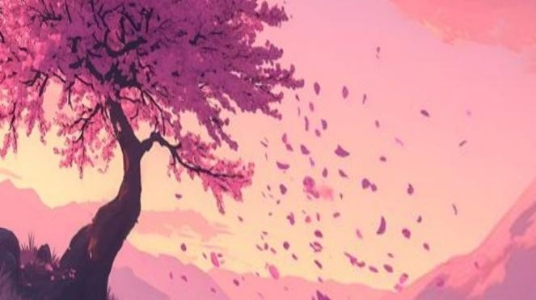

**EXP – 15**

**Perform transformation using Direct Linear Transformation. CODE:**

import cv2

import numpy as np

def compute_homography_dlt(src_pts, dst_pts): A = []

for (x, y), (x_prime, y_prime) in zip(src_pts, dst_pts):

A.append([-x, -y, -1, 0, 0, 0, x * x_prime, y * x_prime, x_prime]) A.append([0, 0, 0, -x, -y, -1, x * y_prime, y * y_prime, y_prime])

A = np.asarray(A)

U, S, Vt = np.linalg.svd(A) H = Vt[-1].reshape(3, 3) return H / H[2, 2]

image = cv2.imread(r'C:\Users\antoc\OneDrive\Desktop\Course CV\LAB\src\img3.jpg') if image is None:

print("Error: Could not load image.") exit()

h, w = image.shape[:2]

src_pts = np.float32([[100, 100], [w - 100, 100], [100, h - 100], [w - 150, h - 150]])

dst_pts = np.float32([[0, 0], [w, 0], [0, h], [w, h]]) H_dlt = compute_homography_dlt(src_pts, dst_pts)

transformed_img = cv2.warpPerspective(image, H_dlt, (w, h)) cv2.imshow("Original Image", image)

cv2.imshow("DLT Homography Transformed", transformed_img) cv2.imwrite("dlt_transformed.jpg", transformed_img) cv2.waitKey(0)

cv2.destroyAllWindows()

**INPUT: OUTPUT :**

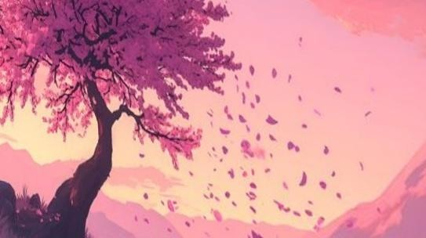

**EXP – 16**

**Perform Edge detection using canny method CODE:**

import cv2

image = cv2.imread(r'C:\Users\antoc\OneDrive\Desktop\Course CV\LAB\src\img3.jpg') if image is None:

print("Error: Image not found.") exit()

gray = cv2.cvtColor(image, cv2.COLOR_BGR2GRAY) blurred = cv2.GaussianBlur(gray, (5, 5), 1.4)

edges = cv2.Canny(blurred, threshold1=50, threshold2=150) cv2.imshow('Original Image', image)

cv2.imshow('Canny Edge Detection', edges) cv2.imwrite('canny_edges.jpg', edges) cv2.waitKey(0)

cv2.destroyAllWindows()

**INPUT:**



**OUTPUT:**

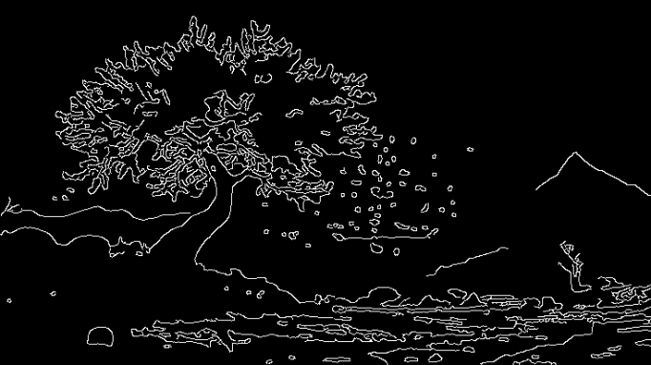

**EXP – 17**

**Perform Edge detection using Sobel Matrix along X axis CODE:**

import cv2

import numpy as np

image = cv2.imread(r'C:\Users\antoc\OneDrive\Desktop\Course CV\LAB\src\img3.jpg' if image is None:

print("Error: Image not found.") exit()

gray = cv2.cvtColor(image, cv2.COLOR_BGR2GRAY) sobel_x = cv2.Sobel(gray, cv2.CV_64F, dx=1, dy=0, ksize=3) abs_sobel_x = cv2.convertScaleAbs(sobel_x) cv2.imshow('Original Image', image)

cv2.imshow('Sobel X Edge Detection', abs_sobel_x) cv2.imwrite('sobel_x_edges.jpg', abs_sobel_x) cv2.waitKey(0)

cv2.destroyAllWindows()

**INPUT:**



**OUTPUT:**

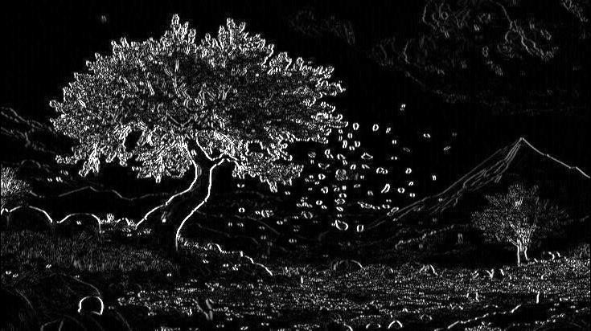

**EXP – 18**

**Perform Edge detection using Sobel Matrix along Y axis CODE:**

import cv2

import numpy as np

image = cv2.imread('your_image.jpg') if image is None:

print("Error: Image not found.") exit()

gray = cv2.cvtColor(image, cv2.COLOR_BGR2GRAY) sobel_y = cv2.Sobel(gray, cv2.CV_64F, dx=0, dy=1, ksize=3) abs_sobel_y = cv2.convertScaleAbs(sobel_y) cv2.imshow('Original Image', image)

cv2.imshow('Sobel Y Edge Detection', abs_sobel_y) cv2.imwrite('sobel_y_edges.jpg', abs_sobel_y) cv2.waitKey(0)

cv2.destroyAllWindows()

**INPUT:**



**OUTPUT:**

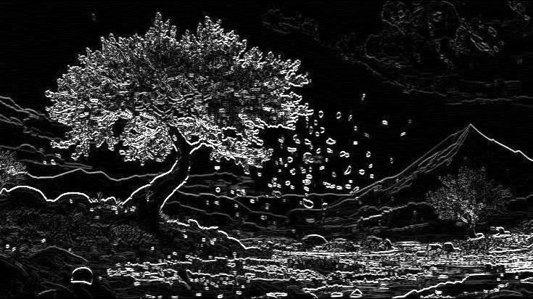

**EXP – 19**

**Perform Edge detection using Sobel Matrix along XY axis CODE:**

import cv2

import numpy as np

image = cv2.imread(r'C:\Users\antoc\OneDrive\Desktop\Course CV\LAB\src\img2.jpg') if image is None:

print("Error: Image not found.") exit()

gray = cv2.cvtColor(image, cv2.COLOR_BGR2GRAY) sobel_x = cv2.Sobel(gray, cv2.CV_64F, dx=1, dy=0, ksize=3) sobel_y = cv2.Sobel(gray, cv2.CV_64F, dx=0, dy=1, ksize=3) sobel_xy = cv2.magnitude(sobel_x, sobel_y)

sobel_xy = cv2.convertScaleAbs(sobel_xy) cv2.imshow('Original Image', image) cv2.imshow('Sobel XY Edge Detection', sobel_xy) cv2.imwrite('sobel_xy_edges.jpg', sobel_xy) cv2.waitKey(0)

cv2.destroyAllWindows()

**INPUT:**



**OUTPUT:**

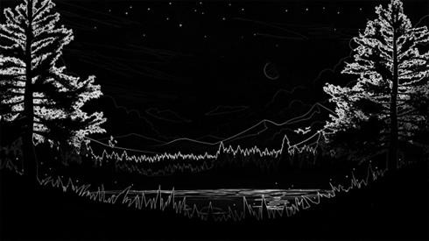

**EXP – 20**

**Perform Sharpening of Image using Laplacian mask with negative center coefficient. CODE:**

import cv2

import numpy as np

image = cv2.imread(r'C:\Users\antoc\OneDrive\Desktop\Course CV\LAB\src\img3.jpg') if image is None:

print("Error: Image not found.") exit()

gray = cv2.cvtColor(image, cv2.COLOR_BGR2GRAY) laplacian_kernel = np.array([[0, -1, 0],

[-1, 5, -1],

[0, -1, 0]])

sharpened = cv2.filter2D(gray, -1, laplacian_kernel) cv2.imshow('Original Grayscale Image', gray) cv2.imshow('Sharpened Image (Laplacian Mask)', sharpened) cv2.imwrite('sharpened_laplacian.jpg', sharpened) cv2.waitKey(0)

cv2.destroyAllWindows()

**INPUT:**



**OUTPUT:**

